**Assignment 1**

1. **Check Positive Number:**

**• Task: Create a flowchart to check whether a number is positive.**

**• Next Step: Write a Java program that checks if a predefined number is positive using an if-else statement and prints the appropriate message.**

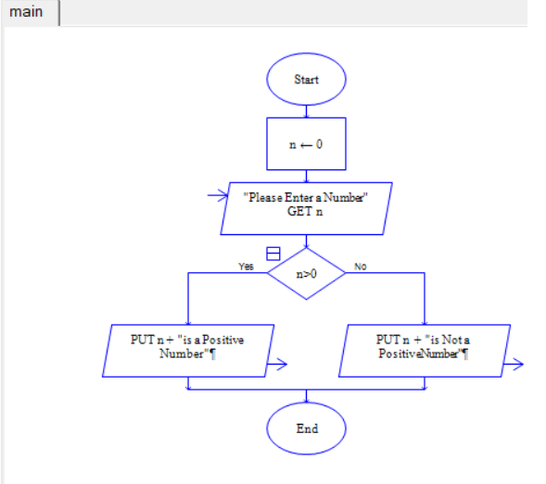

public class PositiveNumber{

public static void main(String args[]){

int num=10;

if(num > 0){

System.out.println("the Number is Positive");

}else{

System.out.println("the Number is not Positive");

}

}

}

1. **Check Negative Number:**

**• Task: Create a flowchart to check whether a number is negative.**

**• Next Step: Write a Java program that checks if a predefined number is negative using an if-else statement and displays the result.**

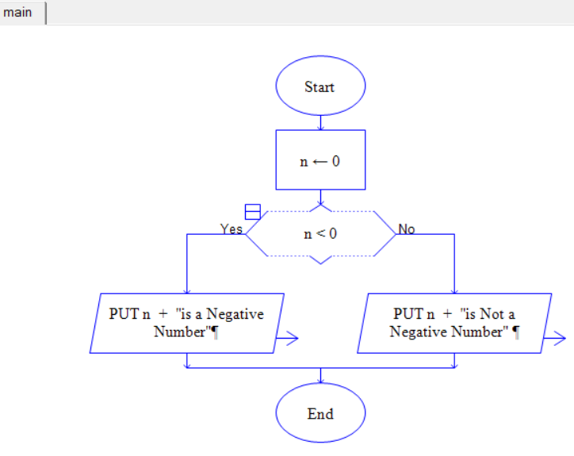

public class NegativeNumber{

public static void main(String args[]){

int number = -4;

if(number < 0 ){

System.out.println("Number is Negative");

}else{

System.out.println("Number is Not Negative");

}

}

}

1. **Check Odd or Even Number:**

**• Task: Create a flowchart to determine whether a number is odd or even.**

**• Next Step: Write a Java program that checks if a predefined number is odd or even. Use an if-else statement and the modulus operator (%) to determine whether the number is divisible by 2 or not.**

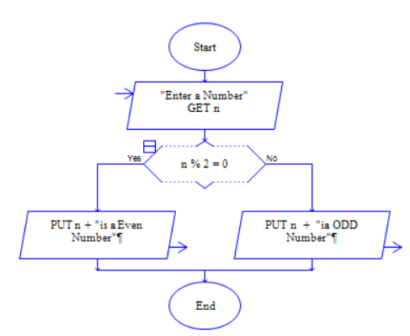

public class EvenOddNumber{

public static void main(String args[]){

int number = 44;

if(number % 2 == 0){

System.out.println("Number is Even");

}else{

System.out.println("Number is Odd");

}

}

}

1. **Display Good Morning Message Based on Time:**

**• Task: Create a flowchart to display a "Good Morning" message based on a given time.**

**• Next Step: Write a Java program that displays a "Good Morning" message if the predefined time is between 5 AM and 12 PM. Use an if statement to implement the logic.**

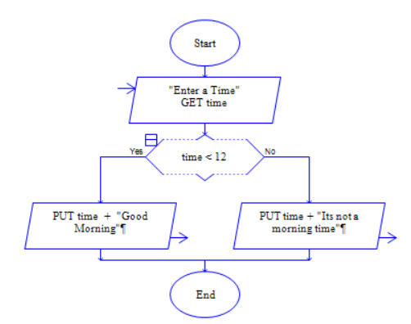

public class GoodMorningMessage{

public static void main(String args[]){

int time = 10; // Predefined time in hours (24-hour format)

if(time < 12){

System.out.println("Good Morning");

}else{

System.out.println("Its not Morning Time");

}

}

}

1. **Print Area of a Square:**

**• Task: Create a flowchart to calculate and print the area of a square.**

**• Next Step: Write a Java program that calculates the area of a square using the formula area = side * side. Use a predefined side length.**

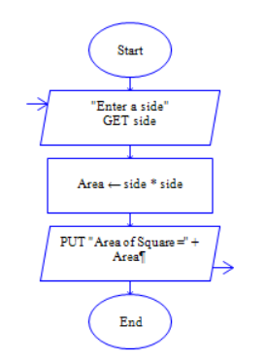

public class AreaOfSquare{

public static void main(String args[]){

int side = 20; // predefined side length

int area = side * side;

System.out.println("The Area of Square is = " +area);

}

}

1. **Print Area of a Rectangle:**

**• Task: Create a flowchart to calculate and print the area of a rectangle.**

**• Next Step: Write a Java program that calculates the area of a rectangle using the formula area = length * width. Use predefined values for length and width.**

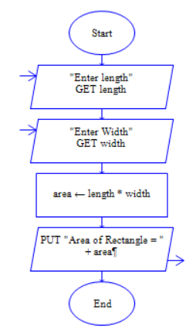

public class AreaOfRectangle{

public static void main(String args[]){

int length = 10;

int width = 20;

int area = length * width;

System.out.println("Area of Rectangle = " +area);

}

}

1. **Find the Largest of Three Numbers:**

**• Task: Create a flowchart to find the largest of three numbers.**

**• Next Step: Write a Java program that finds and prints the largest of three predefined numbers using if-else statements.**

public class LargestOfThree{

public static void main(String args[]){

int num1 = 10;

int num2 = 4;

int num3 = 90;

int largest;

if(num1 >= num2 && num1 >=num3){

largest = num1;

}else if(num2 >= num3 && num2 >= num1){

largest = num2;

}else{

largest = num3;

}

System.out.println("the largest Number is = " +largest);

}

}